Editor’s comments

I am more concerned with the data reanalyze issue. I do not see a clear explanation why the current analysis was not proposed in the first article. Is there anything new, an article that got published, a new method etc… that led you to make the current analysis? At the moment, one may have the feeling that the current paper is just the second part of the first paper, and I think this is detrimental to its acceptance. Can it be specifically added why these analyses were not done initially, and why they are carried out now? Or something like the conclusion of the first paper seems at odd given you did not take into account the Aubert-Fleischl phenomenon, and you here attempt to answer this possible lack? I have been reviewing an article some time ago, Makin (2018), in which he re-analyze some of his own data (see specifically the supplementary part 2), and I think we miss an explanation like this currently.

*The first paper addressed the question whether the internal representation of gravity was used to guide eye-movements and motion extrapolation (see also our preregistration at* [*https://osf.io/8vg95/*](https://osf.io/8vg95/)*). We also introduced a very simple model, which, however, only predicted responses for trials with a long occlusion. It broke down for shorter occlusions and we suggested a possible explanation for this lacking fit for shorter occlusions (an interaction with saccades). Importantly, we never touched upon variability in timing responses, mostly because the main thrust of this project were eye-movements.*

*This second project uses a different approach (modelling and simulations) to answer a different question (this time about variability): what are the parameters of this strong earth gravity prior? From the literature and our previous project it was quite clear that the mean of this prior was around 9.81 m/s². However, it hadn’t been attempted to characterize the standard deviation of this prior. What we see as main contribution of this paper is less the data than the method by which we obtain the this value.*

*While working on the simulations, we also realized that accounting for the Aubert-Fleischl effect would allow our previous model to also account for performance for shorter occlusions. This was, again, not the primary goal of this project, but it seemed relevant and related enough to report it.*

*We agree that both could have been part of the initial paper (although it would have been an extremely long and multi-focal paper), but we simply hadn’t thought of this new research question before the Scientific Reports paper was published.*

We do not know how long the trajectory gets occluded in your experiment, depending on the occlusion ratio, which makes your results hard to compare to the literature. Doing myself TTC experiments, and using occlusion time within 0.5 - 3 s, I often get constant error between -1 s to +1 s, even so I mostly use constant velocities (the errors would be of a higher magnitude I think with acceleration). Hence, if you exclude trials with errors > .5 s and one participant because he has a mean error of .23 s, this is a major bias to me. I see no reason to exclude a participant because his performances are different from the others, this is clearly not an exclusion bias. I would exclude him because of the devices did not properly work, because he did not understood the task, forgot his glasses etc… Excluding trials in which the participants answered before the occlusion is perfectly fine to me for example. If I should use a performance criteria, I would choose one that cannot be questioned and it obviously not acceptable. In the experiments I am doing, I generally remove errors above 3 s. Here you are removing errors / participants that I would never dare considering as outliers. I think that by excluding these trials and participants, reducing the error toward 0 ms and the variability as you do, it is not surprising to confirm the participants perform well and confirm the existence of a 1g model. If existing, this model should deal with the complete variability of the data, not only on the selected trials.I would therefore strongly suggest to include these trials / participant, and see it this affect the outcome of the analysis.

*Applying the criterion of an absolute error of < 0.5 after removing subject 9 results only in a loss of 269 trials, that is 2.2% of the remaining trials. As visible from the (new) Supplementary Figure 1, where the intermittent lines indicate the cutoff criterion of +/- 0.5s, we are not excluding very few trials. Another common approach, discarding all responses that are more than 1.5 times the interquartile range above the upper quartile or below the lower quartile, would lead to exclusion of 516 or 4.2% of the remaining trials.*

*Regarding subject 9, we have the strong worry that their performance was influenced heavily by other biases (such as VR presentation); as you can see in Figure 1 and 2, their performance is extremely different from the other subjects. We did, however, include them in our original hypothesis testing (in the Scientific Reports paper), and are not strongly opposed to including them in the present paper either. In fact, it is likely to only affect the fit of the mean predictions of our model; their variability is quite similar to the other participants. We therefore included s09, but excluded the author (as per Reviewer 2’s request) and adjusted the exclusion criterion to 2 seconds, which represents about 250 % of the longest occlusion duration. This led to removal of 216 or 1.7% of all trials that remained after exclusion of the author’s data. In Figure 1, we visualize the data before removal of outliers, and in Figure 2, we visualize the data after removal of outliers. Please note the different y scales.*

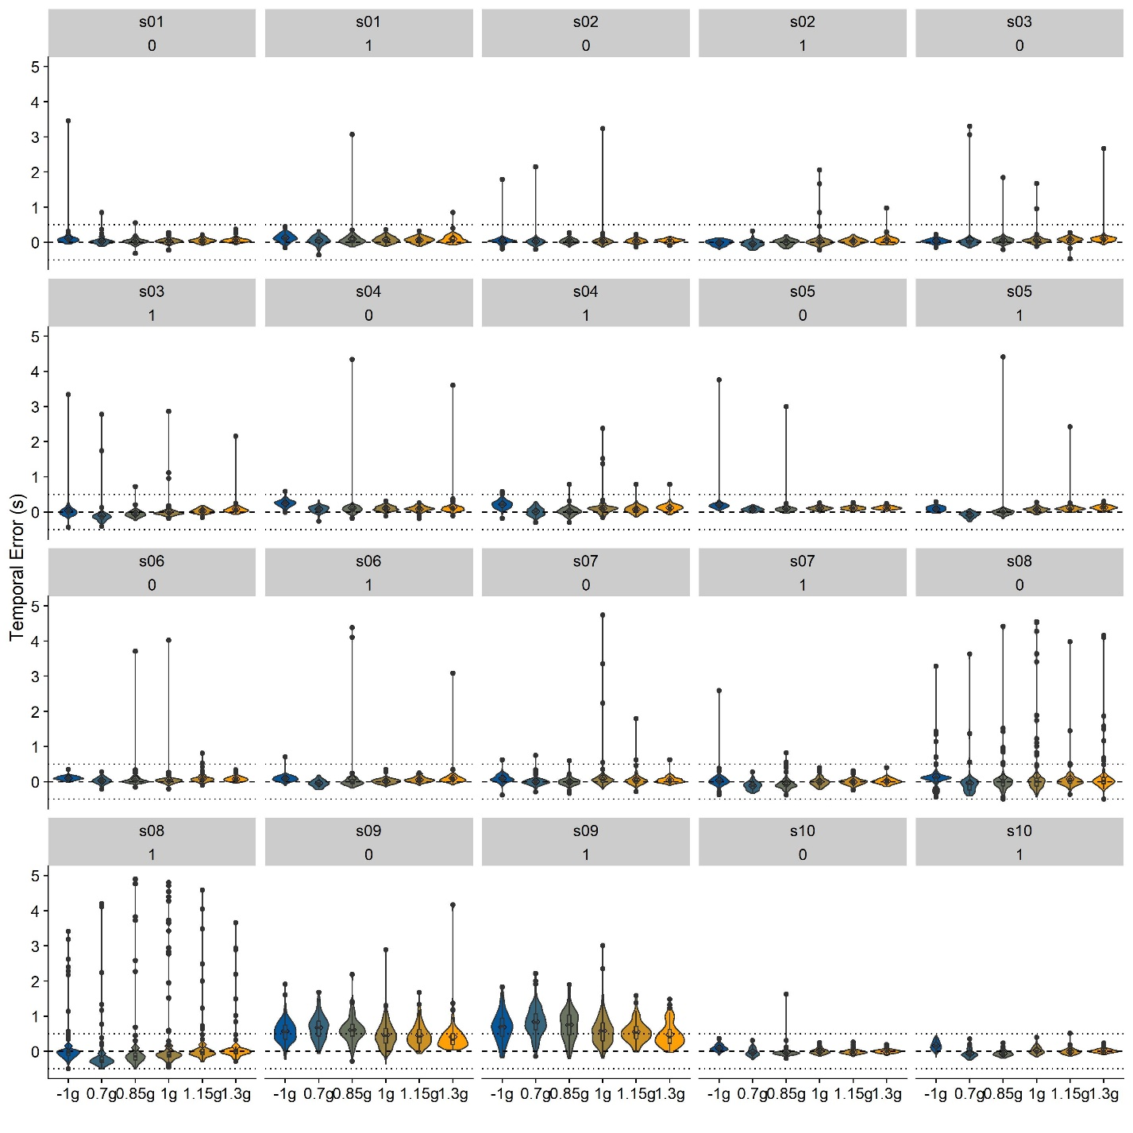

Figure

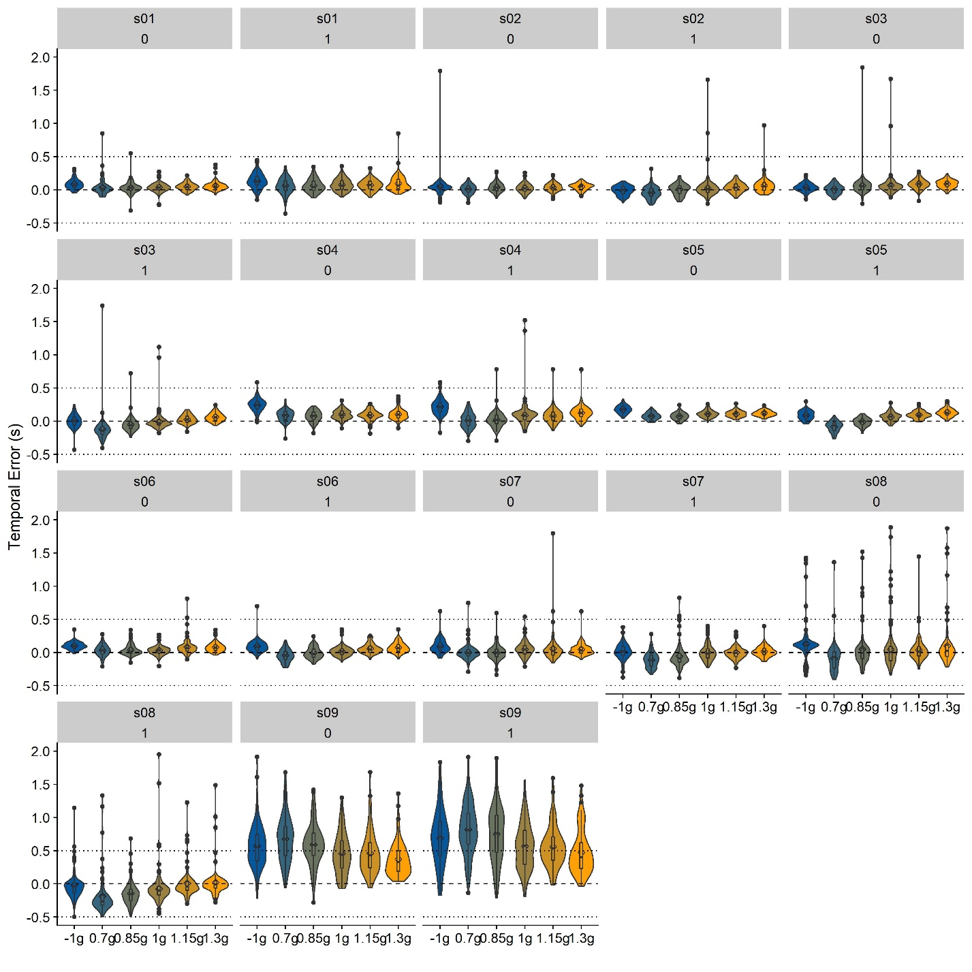

Figure

5. Review Comments to the Author

Please use the space provided to explain your answers to the questions above. You may also include additional comments for the author, including concerns about dual publication, research ethics, or publication ethics. (Please upload your review as an attachment if it exceeds 20,000 characters)

Reviewer #1: The target manuscript aims to expand a Bayesian model, previously put forth by the authors, to account for timing errors of ball undergoing parabolic trajectories either in accordance or counter to earth's gravity. As an improvement from previous efforts, the authors explicitly include what could be expected from the Aubert-Fleischl effect. While doing so, the authors uncover a mismatch between the mean timings, the normal distribution used to model gravuty as a prior and a Bayesian explanation of the found variability. Overall, the manuscript is very interesting and well written. The assumptions for the modelizations are very well clarified and I found several of the steps particularly clever. I honestly do not think I can provide any feedback which would further improve this manuscript, apart from a few minor details:  
  
1. Abstract, "while expands the range" - there seems to be an error in this sentence;

*Addressed*

2. Page 3: While both the Bayes Theorem and the explanation of the Bayesian framework are clear by themselves, it would be better to link them more closely (e.g., by explicitly stating to which parameters in equation 1 does the prior [P(A)] and the Likelihood [P(B|A)/P(B)] refer to - I know this should be obvious for most readers, but it would help the readability of this section);

*Good point!*

3. Page 8: "Figure 3: Temporal errors (...)" - this excerpt seems to be a figure caption. In fact, the first sentence reads the same as the caption for Figure 3. There is, however, an isolated sentence in this paragraph which do not seem to fit the text or the caption: "illustrated the distributions...". Please either remove these sentences or, if meant to convey what can be seen in the Figure, please reformulated it;

*Thank you, addressed.*

4. Page 11: "Figure 4 visualizes the mean errors" - I am not an english native speaker, but the verb "visualizes" sounds odd in this context (for a non-native speaker it sounds as if the Figure is activelly visualizing the mean errors); if this turns out to be a correct usage of the term, please ignore this comment;

*Addressed.*

Reviewer #2: The authors report an experiment testing the existence of a Strong Gravity Earth Prior (SGEP) in a coincidence timing task. The authors aim at determining the mean and the std of the SGEP. The submitted paper calls for two other articles already published by the authors, among which one reports one part of the collected data (eye-tracking) gained in a single experiment.

*We have published one paper based on this dataset (in Scientific Reports), not two. This first paper contains traditional analyses of both behavioral tasks (ocular pursuit and timing responses). After publication of that paper, we started to be more interested in whether we could characterize the gravity prior not only in terms of its mean, but also in terms of its standard deviation. While this is of course related to the previous analyses, we believe that the present paper goes way beyond (re-)reporting the behavioral data, both in terms of its research question (“can we fully characterize the gravity prior?” rather than “Do humans rely on gravity to guide eye-movements and interceptive timing?”) and its modelling and simulation-based approach.*

The remaining data (temporal errors) are used in the present submitted paper. The first result of the experiment is that the Aubert-Fleischl phenomenon can account for the mean of SGEP. The second result of the experiment is that the variability of the SGEP can be retrieved from participants’ button-press temporal variability. I agree that the work is for some aspects interesting. The experimental paradigm neither measurements are not very innovative but the scientific approach sounds good. Concerning the flow of the paper, the motivation to access the mean of SGEP can be easily understood for the non-specialist reader. Results can be easily understandable too. Indeed, there is a theoretical value of g and one can compare it to the participants' mean percept. The second goal of the experiment (“determine the standard deviation of the strong gravity prior” p.2) is for me much more obscure. Are there any examples of the measure of the standard deviation of Priors in the literature? What would be the expected value of it? This leads to a difficult interpretation of the authors' conclusions: “we are not able to fully disentangle different sources of noise in our data”.

*There are studies on optimal integration of prior information with online evidence. These studies typically manipulate the standard deviation of the prior by means of the stimulus they represent. We are attempting to measure the standard deviation of a prior that is established by interaction with the natural environment. As per our introduction, we would expect the standard deviation of this prior to be relatively low. This is because only a very narrow prior can attract the mean of the posterior as strongly as reported in the literature, and as we found in our experiment (as previously reported). If we were pressed to put a number on our prior expectation of its standard deviation, we would choose 10% of its mean. That is, it would be represented more precisely than linear velocities.*

Additionally, I do not like very much splitting a single experiment into several papers since it misleads the reader about the original experiment. Here, the reader can for instance not be aware of the experimental constraints (e.g., calibration process) linked to eye-tracking for participants that are however part of the experiment but too briefly reported. Moreover, this looks for me a rentability approach rather than a scientifically motivated approach. Temporal judgment and oculomotor behavior were linked, why spreading them?

*We are aware that this impression might arise. The motivation for the present simulations arose after the behavioral results were already published. The focus of this manuscript goes beyond the scope of the previous paper, and in our opinion, it is not unheard of to use published datasets to model underlying cognitive processes. Please note that we did not separate ocular behavior and manual judgments. We report the results for both tasks in the previous paper. The present manuscript, in turn, focusses on computational aspects behind these behavioral results.*

Finally, some paragraphs are strictly identical between papers without any further checks. For instance, can the authors justify that “The projectors introduced a delay of 0.049259 s (SD = 0.001894 s) “ (p.6)? I would be interested in an instrument able to measure events shorter than ms… I noticed several other points that at least request a cross-check. This gave to me a weird first impression of the work.

*Our lab technician measured the delay between XXX and XXX XXX times, independently of this project. The value reported here corresponds to the mean across all of these trials. We have been using this value for all experiments conducted with this setup. We adjusted the manuscript to reflect that this is a mean value.*

Experimentally, I’m very annoyed with several aspects of the experiment, despite some parts of the experimental protocol and data were already published otherwhere.  
- My first concern is about the sample size. I can not understand how one of the authors can participate in such a psychological experiment and strongly suggest to remove its data. All participants must be naïve in most of the experiments in visual psychology. Additionally, I found the remaining sample of 8 participants (given that s9 was excluded from analysis, results sections p.9) too weak. The question looks to be already raised by a reviewer in the 2019’s paper since a “justification of sample size” paragraph appears in it. This, however, does not convince me.

*While certainly not the most recommended approach, being one’s own participant is, in our understanding, not an uncommon situation in our field. It is generally assumed that there is not enough voluntary control over performance, and in fact, the author’s performance is very similar to the other participants’ performance. However, we are very sympathetic to this concern and repeat the simulations without the author’s data. As per the editor’s request, we include s09, which brings us back to an n of 9.*

*The power analysis (reported in the justification of sample size section) was conducted before data collection (please see also our preregistration under* [*https://osf.io/8vg95/*](https://osf.io/8vg95/)*). While we agree that a higher n is always desirable, we found under quite conservative assumptions that a sample size of 10 was sufficient to detect effects. Note that the power analysis was conducted with the eye-tracking task in mind, not for the time-to-contact estimation. However, considering the effect sizes observed in the timing task, even 8 participants would be enough to achieve a power of nearly 1. This is, of course, assuming that the inter-subject variability we find in our dataset is representative of the variability in the overall population.*

Finally, if the data used in the present paper were gained in a previous experiment (Jorges, Lopez-Moliner, 2019) as claimed p.4 “we use the data from our previous study (Jörges & López-Moliner, 2019)”, why are the gender of participants different between this paper (5 females) and the previous paper (3 females)?

*That is a mistake in the current manuscript and we apologize for this oversight. The numbers from the published paper are correct. We corrected this mistake.*

- My second concern is about the number of experimental conditions (section procedure, p.6-7). It looks that participants performed 48 training trials + 3x320 trials + 64 trials for the “1 block of 1g/-1g motion" = 1168 trials. How long spent the experiment? Do you think that such an amount of trials did not let to a standardized perception? Do any participants report any fatigue or ennui?

*The experiment was about one hour of testing overall. Calibrating the eye-tracker before the session and between the blocks added on average another 30 minutes to the experiment. The participants did report being bored by the task at times, but dividing the experiment up in four blocks meant that they could take breaks every 15 minutes.*

- My third concern is about the repetition number. Since the paper focuses on the variability of prior, why not testing less trajectory but much more repetitions? You’re not dealing with 3D motion variability, just button-press. 8 repetitions of a temporal error are too low for supporting the authors' test about the variability of SGEP.

*We present each combination of stimulus variables 24 times overall: eight times in each of the three 0.7g-1.3g blocks. In the -1g/1g condition, we only had two different gravity values and thus managed to accommodate all 24 repetitions in one block. We made this clearer in the manuscript.*

- My fourth concern addresses the data collection. First, can the authors guaranty that the mouse button can accurately measure temporal error? In such an experimental paradigm, high-temporal accuracy devices as E-Prime are usually required since the USB port and internal clock of the computer can delay the monitoring of USB mouse signal. Do the authors perform some test-bed ?

*We have not performed any tests on delays in the mouse responses.*

Moreover, at no moment, the authors report the duration of the stimulus, which makes temporal data difficult to understand.

*This was indeed an oversight, which we corrected. Thank you!*

Second, in the apparatus section (p. 6), why not offering any details about the eye-tracking device? post-processing methods? Type of dependent variable analyzed? This is an odd oversight because some interpretations resort to eye-tracking data (cf. simulations section, p10. “Our ad hoc explanation of this discrepancy was that subjects were often executing a saccade when the ball returned to initial height” “ and “Our subjects were specifically instructed to follow the target with their eyes, and the eye-tracking data we collected that they generally did pursue the target”). The authors should at least mention their previous paper and report results.

*We did not want to repeat results from our previous paper (for the reasons the reviewer outlined above); we added references to the previous paper to the passages in question.*

I would finally like the author to carefully explain the ballistic of the ball trajectory and the related perceptual information available for perceiving g. Indeed, in a fully visible trajectory, g can be retrieved from different sources. In their experiments, authors occlude some parts of the trajectory. Naïve readers must understand what information remains available from all information usually available. This must also be connected to real-world illustrations, that must convince the reader that humans usually have to succeed in performing such tasks (e.g. in sports for instance) and that the experimental paradigm can mirror human perceptual processes

Minor comments :  
- Participant section (p.4), why “remaining participants”?

*This was an error, which we adjusted.*

- Apparatus section (p. 6). Does the virtual scene be enslaved to the participants' viewpoint? Perhaps the variability of judgments is related to a change in perception of the altitude?

- Stimuli section (p.4). Does the ball spin during its trajectory?

*The ball does not spin. We added this information to the manuscript.*

- Stimuli Section (p.5). please details why the -6.15m depth from the observer was chosen and the perceptual consequences of such a parameter (FOV, role of stereoscopy, usual perceptual processes operating at this range of distance, etc.)

[ADD]

- I found the paragraph “On a theoretical level […] to recover its physical velocity from retinal motion” (p.3) very crude, without any theoretical references to any framework while it is connected to a specific field of visual psychology. Optic Flow carries a lot of visual information that alone can be used to disambiguate environment perception for ecological psychologists. Also, for cyberneticians, “precise estimate of the observed world” is achieved through internal models. Please add references and pragmatic examples that support the authors' claims.

[ADD]

- Result section (p.8). The reference to Figure 3 is weirdly inserted in connection to the following explanation in the text. Please correct.

*Thank you, we corrected this mistake.*

- Result section (p.8). The “following test model” looks to be identical to the first equation (p.7). Why going back regarding the previous equation?

*These equations refer to different types of analysis. To test for mean differences (i.e., accuracy), we employ Linear Mixed Modelling (above). Testing for differences in variability (i.e., precision), is not easily possible with regular Linear Mixed Models. We therefore used Bayesian Linear Mixed Modelling (below). While the R packages we use for both analyses use the same syntax, we thought it was opportune to repeat the model specification because it was a different hypothesis.*

- Result section (p.9). I would prefer expressing the temporal errors as a function of the duration of the trajectory to figure out their magnitude.

[HMMM … RATIOS? GOOD IDEA OR NOT?]

- Result section. Please provide all data corresponding to the statistical tests (especially effect size).

[HMMM…]

- The sentence “However, in the case of gravity it seems that the expectation of Earth Gravity overrules all sensory information that humans collect on the law of motion of an observed object. “(p3-4) looks to be a claim without any experimental evidence.

*We added references to substantiate this claim.*

- The Figure 1 is so much underexploited in the text that unfamiliar readers with Bayesian Theory might be loose in interpreting it.

[ADD MORE]

- The reference to “figure 1” in the Section “stimuli”, p.5 looks to be incorrect in the paragraph that refers to the virtual scene (cf. figure 2)

*Corrected, thank you.*

- A missing figure reference had to be corrected in p. 17

[UHMMM … WHAT?]

- “we expect the gravity model not to be activated for inverted gravitational motion” (p. 16) looks to contradicts with “there is some reason to believe that the gravity prior is not completely inactive in upwards motion” (P. 17)

[Add]